A000-AM,C-Costa Rica- Nicoya-Female Effigy-Seated-Polychrome Ceramic-800-1000 CE

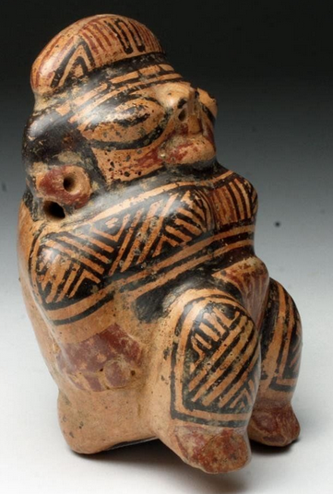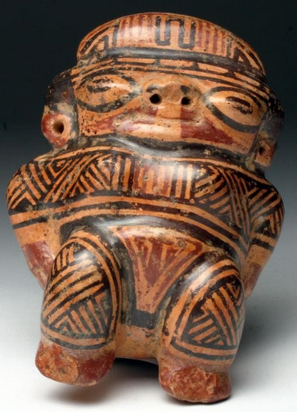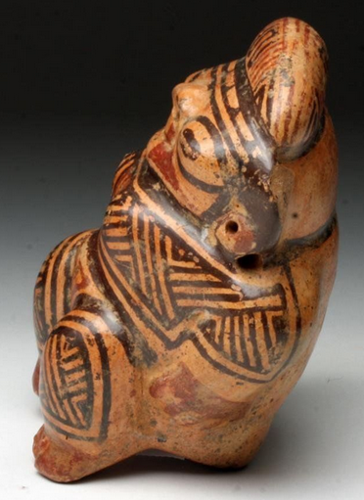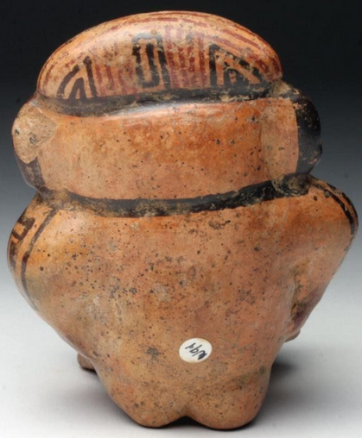

Figs. 1-4. Costa Rica- Nicoya-Female Effigy-Seated-Polychrome Ceramic-800-1000 CE

**Formal Label:** Costa Rica- Nicoya-Female Effigy-Seated-Polychrome Ceramic-800-1000 CE **Accession Number:**

LC No.: [F1545.3.P6](http://luna.wellesley.edu/search%7ES1?/mF1545.3.P6+C67+1988/mf++1545.3+p6+c67+1988/-3,-1,,B/browse)

**Date or Time Horizon:** 800-1000 CE

**Geographical Area:** Guanacaste-Nicoya, Costa Rica-Nicaragua

**Map:**

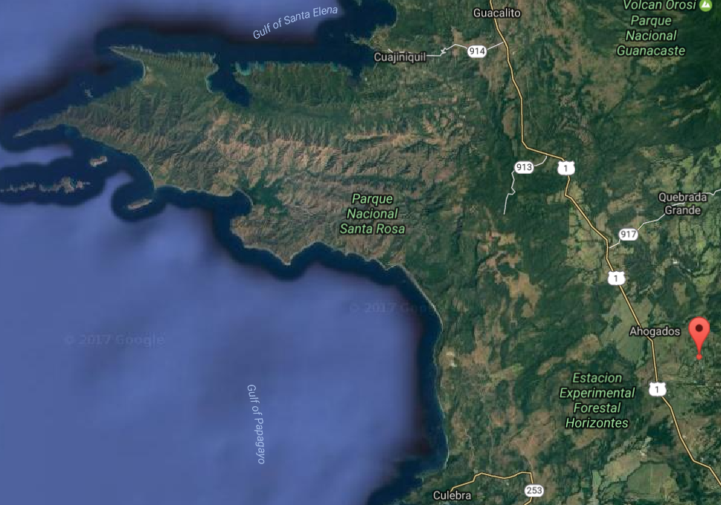

Map after https://www.google.com/maps/ GPS: 10.741681, -85.481599

**Cultural Affiliation:** Guanacaste-Nicoya

**Medium:** Terracotta

**Dimensions:** H: 4 1/3 in, W: 3 ½ in, D: 2 ½ in

**Weight:** Weight: 10.2 oz.

**Provenance:** Ex-Gilbert Martin Collection, Georgia, USA; Ex-Artemis Gallery

**Condition:** Excellent condition.  Has one chip on back of left ear and does not affect visual appearance.

**Discussion:** This female effigy possesses the elegant styling of the Guanacaste-Nicoya artisan. Produced with a striking trichromatic style in red and black on cream ground, it has a high-gloss burnished finish demonstrating fine technique. The entire surface is ornately decorated with flowing geometric patterns adorning her headdress, body, and costume accentuating the curves of her body. Black spotting particularly visible on backside represents manganese oxide deposits that develop with prolonged burial. This female effigy was most likely placed in a grave to grant the inhabitant rebirth in the afterlife.

**References:**

**Lange, Frederick W. 1988. *Costa Rican art and archaeology : essays in honor of Frederick R. Mayer.*** [Boulder, Colo.] : University of Colorado.

### ****Clifford, Paul. 1985. *Art of Costa Rica: Pre-Columbian painted and sculpted ceramics from the Arthur M. Sackler collections*, edited by Lois Katz.**** Washington, D.C.: Arthur M. Sackler Foundation: AMS Foundation for the Arts, Sciences and Humanities.

**LC Classification:** F1545.3.A7

**Date or Time Horizon:** 500 AD/CE–1000 AD/CE

**Geographical Area:** Linea Vieja area, Costa Rica

**Map, GPS:** 10.741681, -85.481599, after https://www.google.com/maps/

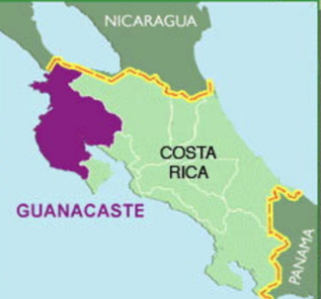

**Cultural Affiliation:** Guanacaste­-Nicoya

**Media:** terracotta, clay slip, red and black pigment.

**Dimensions:**

**Weight:**

**Condition: Original.** Some spalling on the surface shows the effects of moisture in the grave,

**Provenance:** Original.

Discussion:

This elaborately-painted, burnished and carefully hand-modeled seated female nude ceramic figure is portrayed with polychrome brown-on-cream-colored linear and geometric body art and tattoos covering her shoulders and chest. She is posed seated (suggesting an elevated social rank) with arms akimbo, hands resting on her torso with legs extended. She appears to be in a trance state with her eyes closed. There are five vent-holes; two at the nose, two at the femurs and one at the cervical base of the neck. Two suspension holes made this an amulet.

Guanacaste-Nicoya archaeological periods follow the periodization of Lower-Central America (Lange 1996) in six periods that spanned 12,000 BCE-1550 CE/AD. This polychrome ceramic comes from **Period V** (CE/AD 500-1000) in which there was a return to exploitation of marine resources, expanding habitations, and the development of Guanacaste-Nicoya polychrome ceramics of which this is an example in the Papagayo style: a cream-colored ceramic with polychrome motifs, which was widespread after 700 CE/AD. This ceramic with the figure’s eyes closed as if in a trance suggests she is one of the ritual specialists with shamanistic powers. It was probably placed in a grave in the Linea Vieja region where juxtaposed graves have stone-lined rectangular walls and floors that have preserved many ceramics in good to excellent condition (Stone 1972: 27).

**References:**

Abel-Vidor Suzanne, Dirk Bakker, Detroit Institute of Arts, Jay I. Kislak. 198. *B****etween continents/between seas: Pre-Columbian art of Costa Ri*ca.** New York: H.N. Abrams; [Detroit]: Detroit Institute of Arts.

Evans Toby, Susan and David Webster, eds. 2001. *Archaeology of Ancient Mexico and Central America: an Encyclopedia*. New York: Garland Publishing.

Lange, Frederick W., ed. 1996. *Paths to Central American Prehistory*. Boulder: University of Colorado Press.

Stone, Doris. 1972. *Pre-Columbian man finds Central America: the archaeological bridge*. Cambridge: Peabody Museum.